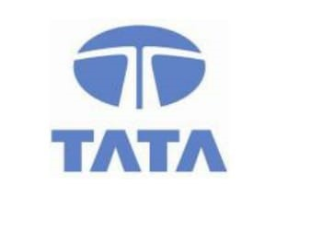

**EXPRESSION OF INTEREST (EOI)**

The Gist of Memorandum of Understanding (MoU) is intended to cover a specific collaborative effort between **TCS** and **ANKUSH WELFARE SOCIETY** under the “**SELF EMPLOYABILITY TRAINING PROGRAMME** (**SET Programme**)” driven by ANKUSH WELFARE SOCIETY, under which TCS will provide quality Specific Oriented **CERTIFICATION** of **COMPUTER APPLICATIONS**. This Application Standard Level may be attributed to Business Process Services/Management related Domains at the Grace Level above Xth Standard.

ANKUSH WELFARE SOCIETY being a Growth Promising Company indulging technical consulting services in Coaching and Other Skill Development Activities (PMKVY, RPL). Appreciable for Intense Effort of Development in Rural & Urban Areas.

TCS make a Referential Note of the Training Activities undertaken by ANKUSH WELFARE SOCIETY and be sure the Eligible Candidates of the Specific Programme redeem the need of Scholarship condemned by the Company.

At the End of Course all the Outstanding Contributed Students will be showcased with a **CERTIFICATE**. Exemplary Recognition of **SCHOLARSHIP** is done based on Participation.

The Commencement of the Programme is from August 2017

**TATA CONSULTANCY SERVICES LTD** **ANKUSH WELFARE SOCIETY**

Signature: ____________________ Signature: ____________________

Dr.D.RANJAN N.SRI VARUN CSR TEAM – INDIA C.E.O

